2024/25價值觀教育傑出教學獎
教案

學校名稱：聖保祿學校
1. 教學單元／課題：
校本跨學科「生物 X 經濟」課程:疫起共對為家園
School-Based BIO X ECON Program: Vaccination and Community Health
2. 教學時間： | 40 分鐘
3. 預期學習成果：
知識： |  | Biology:  The students should be able to explain:  - Biological principle of vaccination and its impacts  - Biological base of certain infectious diseases (2007)  Economics:  The students should be able to explain the positive externality, in terms of  - The fundamental concept of under-consumption  - External benefits of being vaccinated  - Government budget on long-term medical expenses and burden (2007)  STEAM:  The students should be able to use of a self-developed simulation SIR model to  - calculate herd immunity thresholds  - discuss the ethical importance and underlying values
共通能力／技能： |  | Basic Skills:  - Communication and Information Technology (IT) Skills  Thinking Skills:  - Critical-thinking and Problem-solving Skills  Personal and Social Skills:  - Self-learning and Collaboration Skills
價值觀和態度： |  | Values Education:  - Core Values:  - National Identity: Filial Piety  - Responsibility  - Other Values:  - Unity and Empathy  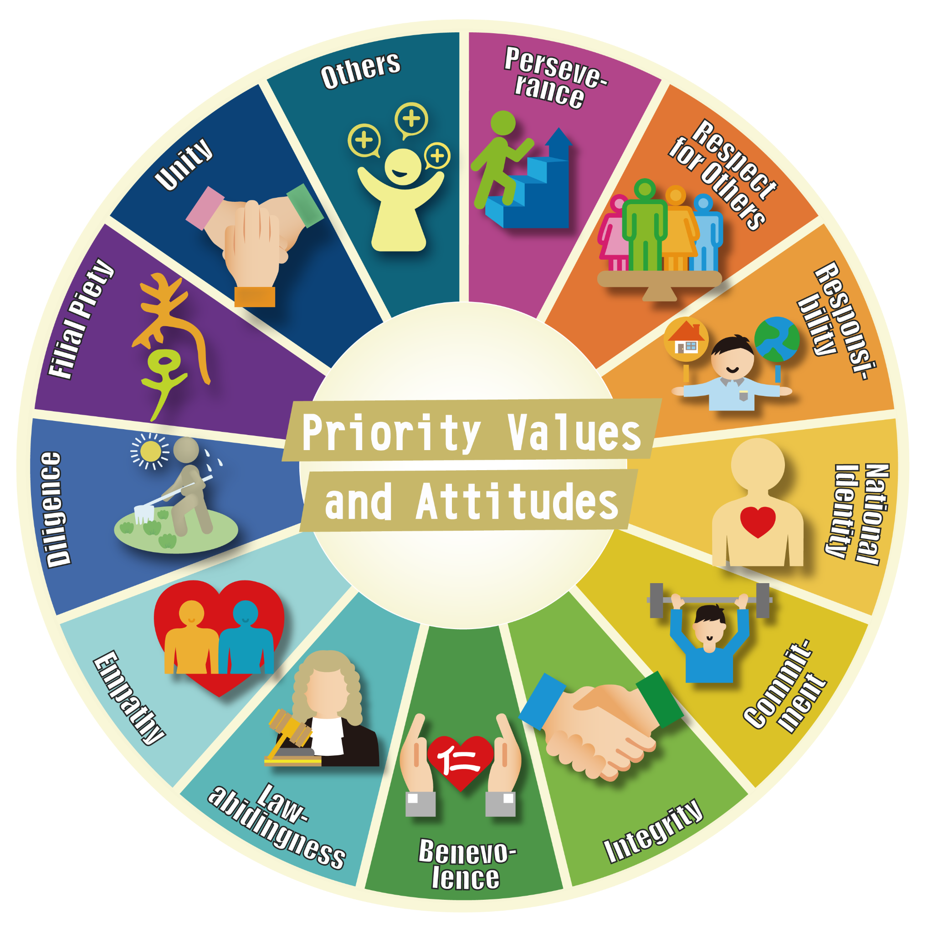  Attitudes:  - Be open-minded and understand the pros and cons of being vaccinated to our society  - Understand the government’s economic benefits and costs in providing vaccination to the citizens  - Achieve a long-term health planning and be self-responsible through risk-benefit analysis  - Strengthen the relationship between students, society and the government  - Strengthen the information literacy among students
教學中凸顯的首要培育價值觀和態度（包括校本價值觀）︰（最多4項） |  | School-Based “7Cs” Core Values:  - Charity, Conscience, Confidence, Courage, Creativity, Competence and Commitment  - Contribute positively to their home, profession, society and homeland  Sustainable Development Goals (SDGs):  - The formal curriculum will incorporate the SDG Goals  - SDG 3: Good Health and Well Being  - SDG 11: Sustainable Cities and Communities  Adoption Practice: Catering Learner Diversity:  - More advanced and cross-subject materials can be offered to the gifted students  - Implement Bloom's Taxonomy in both curriculum and assessment design framework to enhance the overall learning and teaching effectiveness (1956)  - Project works can enhance the overall “assessment for learning” and “learning how to learn” effectiveness  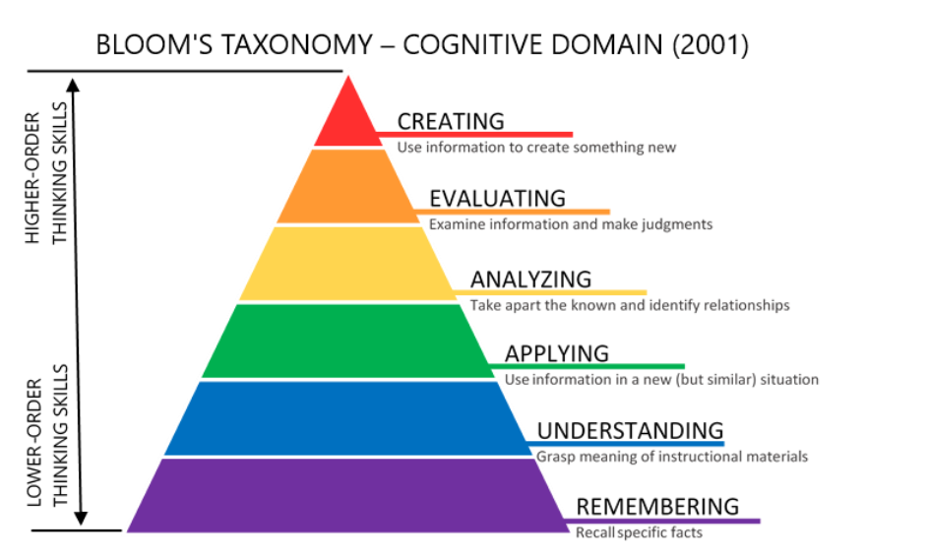  School Core Theme of the Year: 4R Mental Health Values:  - Resilience (Biological effects on vaccination)  - Relationship (To peers, family, society and government)  - Group project and presentation (A3-size poster)  - Community project plan  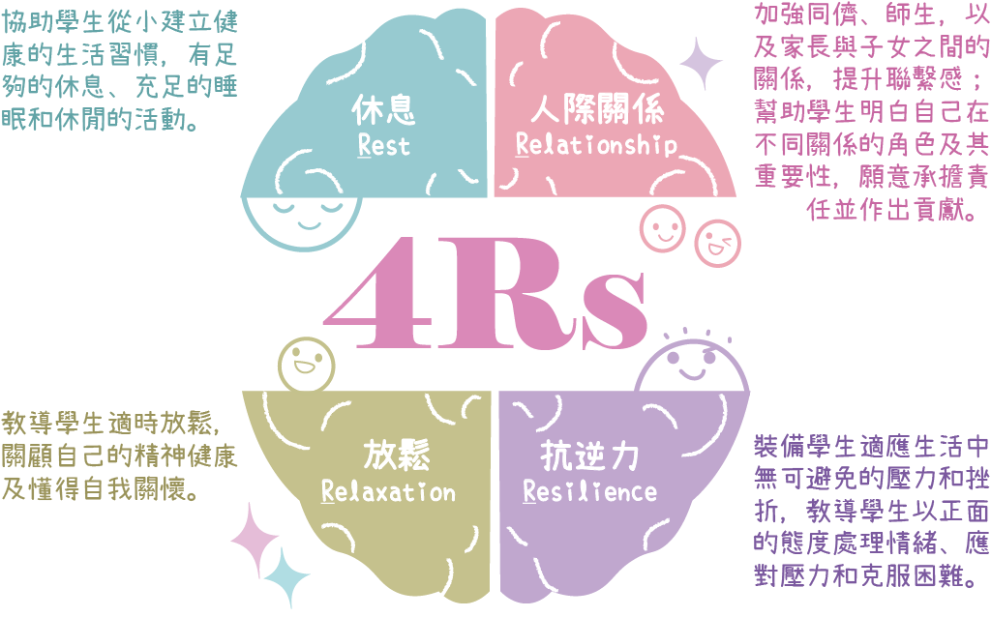

4. 教學流程
學習領域／科目／跨學科範疇： |  | Science (SS Biology)  [Integrated PSHE (Economics) and STEAM] |  | 班別／年級： | S.4
時間 | 學習要點／內容  （請於本部份列出有關的價值觀） |  | 學與教活動（時間） |  |  | 教材／學習材料
20 mins | Learning Objectives:  - Knowledge: Understand the impacts of vaccines on individual and public health; the biological consequences of low vaccination rates.  - Knowledge: Analyze economic costs associated with vaccine-preventable diseases due to vaccine refusal.  - Skill: Develop teamwork, research, presentation and critical thinking skills.  - Skill: Improve the IT (data literacy) skill in identifying fake and accurate online information.  - Attitude: Appreciate the local government in responding to vaccination issues and strengthen the sense of national identity and responsibility on fulfilling “social contract” spirits.  - Attitude: Explore ethical considerations, promote empathy and social responsibility in public health.  Regarding the Poster, the poster should include the following items:  - Introduce the disease and its biological impact.  - Explain how vaccine refusal affects disease spread and public health.  - Discuss economic consequences, using data and examples.  - Highlight ethical considerations and the values involved.  - Incorporate perspectives of different stakeholders.  - Prepare questions, especially regarding ethical and value aspects.  - Other important item(s)  c |  | 20 minutes - Group Presentation and Debriefing  Presenters & Teachers: The remaining 2 groups will present their project work and followed by the follow-up questions.  Other Students: The students are required to fill out the peer evaluation form and provide feedback (two positive comments and one improvement) to the presenters.  Sample Work:  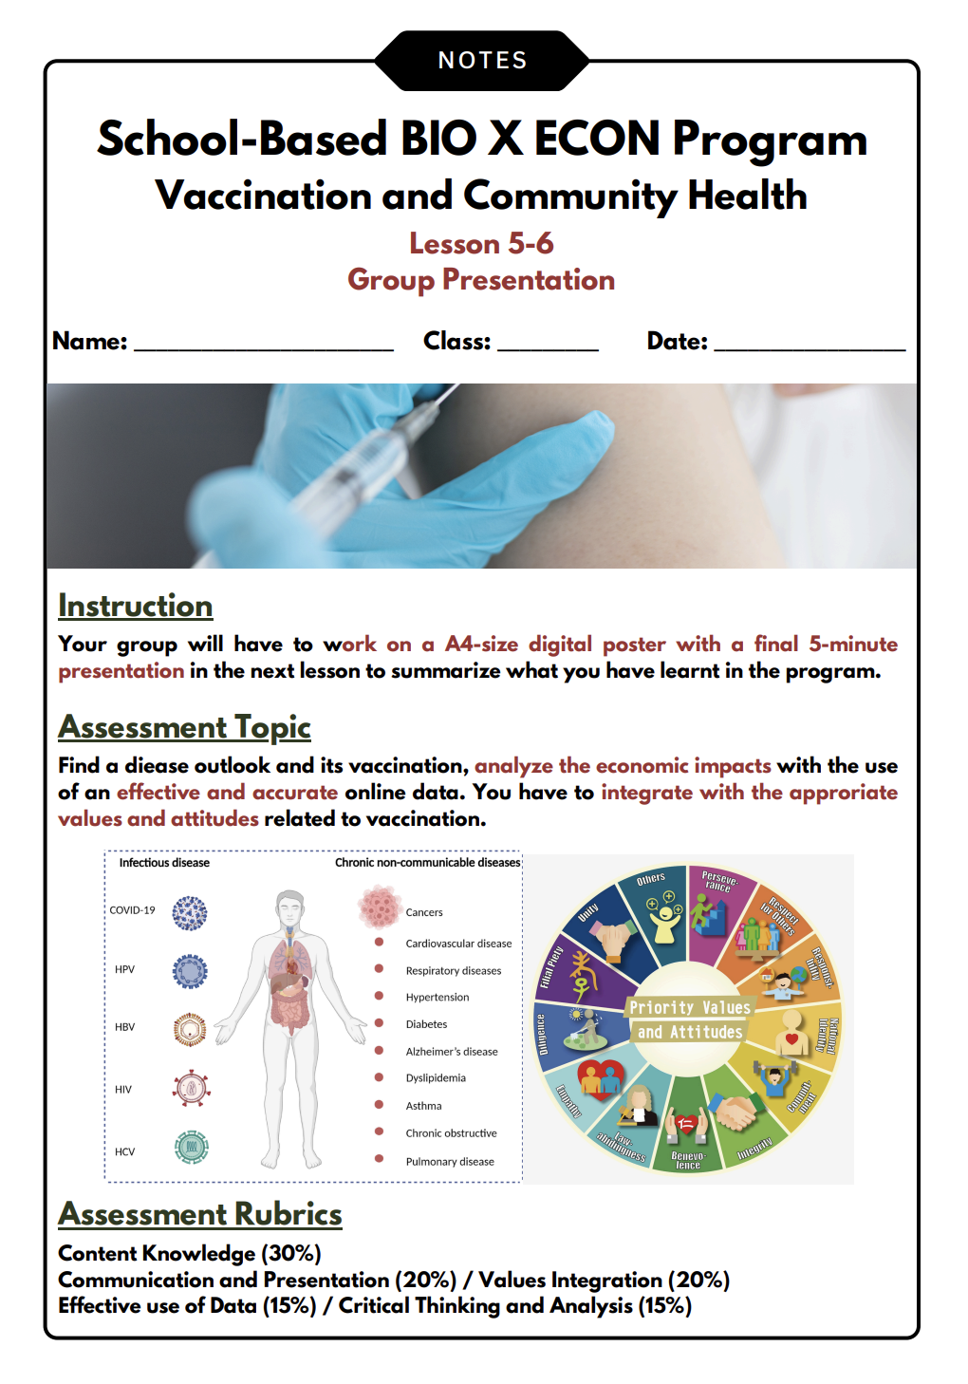  Use of the Assessment Criteria Scoresheet  To ensure the assessment is valid and reliable, a detailed assessment criteria scoresheet with descriptions will be provided for students to reduce the inter-rater reliability. |  |  | Tools:  - A3 Digital Poster  - Smart Board and Mic  - Peer Evaluation Form  - Assessment Rubric
  As the pupils’ learning is often unpredictable, the poster and presentation design can help to validate the unintended learning outcomes, which includes different positive values.
  5 minutes | First group will present
  5 minutes | Teacher will ask the follow-up questions
  5 minutes | Second group will present
  5 minutes | Teacher will ask the follow-up questions
  Assessment Criteria:
  - Content Knowledge (30%)
  - Communication and Presentation (20%)
  - Values Integration (20%)
  - Effective Use of Data (15%)
  - Critical Thinking and Analysis (15%)
5 mins | Learning Objectives:  Short Summary: Recall the learning checkpoints, in terms of  - Basic biological concepts;  - the economic impacts;  - and mathematical modeling (SIR Simulation)  in vaccination with real-life examples.  Values Education: Promote the values of National Identity and Social Responsibility through the understanding of the herd immunity, biological and economic impacts of vaccination. |  | 5 minutes - Brief Summary  Direct Teaching: Provide general feedback on the group project work and recall all the learning checkpoints.  Incorporate the 4Rs Mental Health Charter  - Vaccination can help strengthen resilience (Vaccines prevent illness, both physical and mental well-being).  - Vaccination can help to strengthen the relationship with peers, parents and our community, boosting the sense of national identity and social responsibility. |  |  | Tools:  - A3 Digital Poster  - Lecture Handouts  - Smart Board
10 mins | Learning Objectives:  Prompt the students to think about how they can be socially responsible in promoting the importance of vaccination in our society. It also helps to enhance critical thinking and problem-solving skills.  [Triangle of Teacher Support]  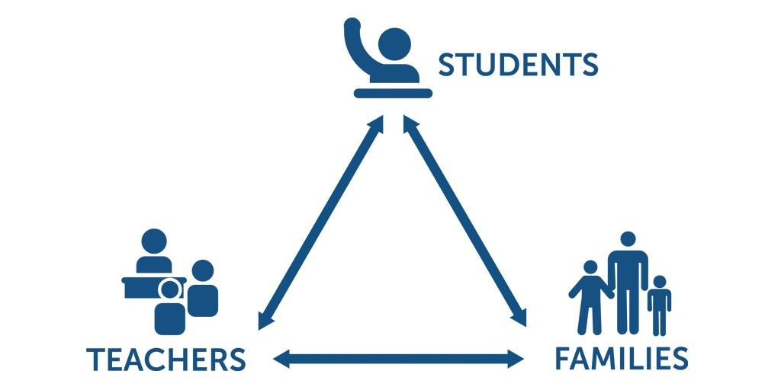  Remark: We also want to involve their parenting education, specifically, how vaccination can strengthen the relationship between the students and their families.  Values Education: The teacher will also induce the important values, which includes:  - Filial Piety and Empathy (the external benefits of vaccination - not only to our parents, also the kids and elderly in the society)  - Social Responsibility and Unity (How can we do more to contribute to our society and strengthen our relationship with it?) |  | 10 minutes - Guided Reflection and Discussion  Student-Led Discussion: Hold a structured discussion to reflect on what they can do further.  c  Pose reflective questions:  - Share reflections on what they learned.  - Discuss how values play a role in public health decisions.  - "What values did you identify as important in addressing vaccine refusal?"  - "How do our personal values influence our decisions about health?"  - "In what ways could you (and with your parents) help or contribute to our homeland?”  To fully utilize students' potential, they can think of suggestions to boost the vaccination rate in our community. |  |  | Tools:  - Lecture Handouts  - Smart Board
  Key Focus Question: What and how can the students achieve after the lessons?
5 mins | Learning Objectives  By adopting the teaching pedagogy of 'Learning by Doing,' students will use the same idea in the digital poster to create a project campaign that could be implemented in our society.  It also helps to enhance self-learning and collaboration skills through BYOD policy and flipped classroom initiatives.  Sustainable Development Goals (SDGs):  - SDG 3: Good Health and Well Being  - SDG 11: Sustainable Cities and Communities  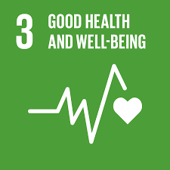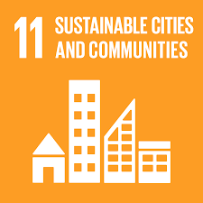  c |  | 5 minutes - Assign Group Work  Explore ways to promote positive values in their communities in the Community Engagement Project.  c  The project should include:  - Clear Objectives  - Target Audience  - Market Research  - Action Plan (e.g. the time, venue and timeline)  - The Values you want to promote  - Evaluation Metrics  Ongoing Role of Subject Teacher:  Use of “Feedforward” to enhance Assessment for Learning and Self-Directed Learning (SDL) initiatives  The project progress can be treated as part of the assessment through grading and timely feedback, which can help improve the work before it is submitted as the final product. Different values can be taught on an ongoing basis outside the formal classroom setting, serving as the self-directed learning experience.  Integration of Both Formal and Informal Curriculum through Interdisciplinary Programs  With more time allocated to the informal curriculum and an emphasis on promoting values and positive education, the summative project can be used to collaborate with other parties, such as a community service team. |  |  | Tools:  - Lecture Handouts  - Smart Board  - Project Description Sheet
  Teachers can co-construct the projects with the students and provide constructive feedback to improve “Assessment for Learning” and “Learning How to Learn” initiatives.
  Align with the teaching pedagogy of “Learning by Doing” Practice - Student-led Project Learning
Supplementary information of the design of the Learning and Teaching Plan (bullet points can be used in this part; in no more than 600 words)

Section 1 - Introduction and School Culture
Value education is essential to whole-person education. Our school has long been considering value education as our ongoing major concern. Embedding the 'Four Key Tasks' design in our teaching and learning, this plan integrates school-based “7C”s and curriculum core values, primarily focusing on Biology while incorporating elements of Economics and STEAM to enhance value education through global and historical perspectives.

Section 2 - Learning and Teaching Strategy
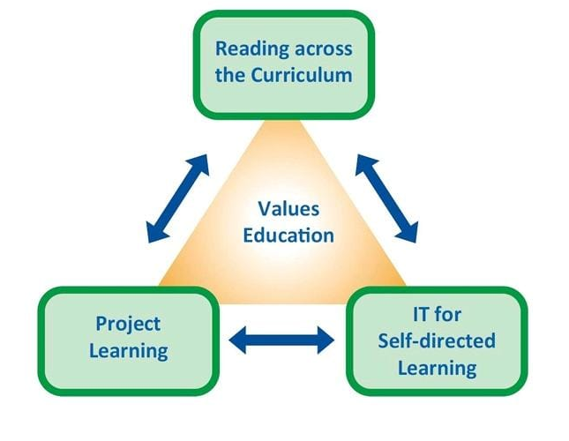  Figure 1: “Four Key Tasks”  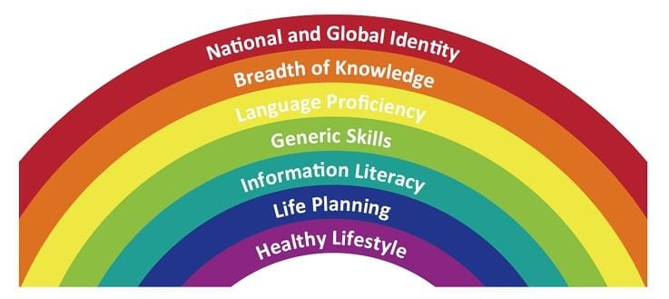  Figure 2: Seven Learning Goals of Secondary Education  Figure 3: Twelve Priority Values  Figure 4: Bloom’s Taxonomy | 2.1 Reading Across the Curriculum  2.1.1 Cross-disciplinary Learning through Biology and Economics  Using Biology as the main focus, students explore vaccination principles, benefits and risks. They analyze related policies such as mandatory vaccination and its economic incentives. Common diseases like HPV were discussed to enhance global identity. Through PSHE (Economics) integration, students understand vaccination's external benefits to society (achieving a well-balanced healthy lifestyle in society) and their responsibility within the social contract - deepening the breadth of cross-curriculum knowledge.  2.1.2 Integration of Bioethics and Social Responsibility  Bioethics discussions help students examine healthcare decisions while recognizing their role in preventing infections and reducing the public healthcare burden. Students learn to evaluate the ethical implications of healthcare policies and their impact on community well-being with a healthy lifestyle and respect for others with empathy, unity, responsibility and commitment towards our homeland.  2.1.3 Differentiated Learning Materials for Student Diversity  Through LAC, reading materials were designed at various difficulty levels to accommodate learner diversity, with basic content suitable for all students and advanced materials for those interested in Economics. Different reading and research papers could improve students’ language proficiency.  2.2 IT for Self-Directed Learning  2.2.1 Digital Tools and Information Literacy  We utilize various IT tools to enhance learning effectiveness while promoting information literacy through proper citation of online sources. Students develop critical thinking skills in evaluating and using digital resources effectively.  2.2.2 STEAM and Data Interpretation  Students engage with STEAM elements through simulation models, developing understanding through data interpretation to enhance IT, mathematical and modeling skills. They learn to make probability-based predictions about future events, emphasizing community health and collective responsibility.  2.2.3 BYOD Implementation and Bloom's Taxonomy  Following the BYOD Policy, the curriculum incorporates Bloom's Taxonomy (1956) throughout the entire curriculum and assessment design to further strengthen the breadth of knowledge effectively, starting with basic vaccination concepts in Biology, followed by an analysis of impacts economically, and culminating in the creation of their own project work as a summative assessment.  Digital student-led research process enhances information literacy skills and strengthens integrity and national identity through policy analysis.  2.3 Project Learning  2.3.1 6C Deep Learning Framework Implementation  The curriculum incorporates Creativity, Communication, Collaboration, Critical Thinking, Character, and Citizenship as learning values. Students demonstrate these competencies through their project work and discussions. In-class debate and final presentation could also strengthen students’ language proficiency and communication, critical thinking and analysis skills.  2.3.2 Co-teaching and Professional Development  Co-teaching enhances overall teaching quality, with teachers actively learning beyond their expertise. This collaborative approach supports professional development and enriches the cross-curriculum teaching experience.  2.3.3 Student-led Assessment and Collaborative Work  Students collaborate using electronic devices for final assessment projects, demonstrating their understanding of vaccination concepts through creating their own piece of work. This student-led approach has shown improved academic outcomes, particularly effective with active and talkative students, could have a memorable and long-lasting personal reflection in values education.

Appendix: Learning Materials

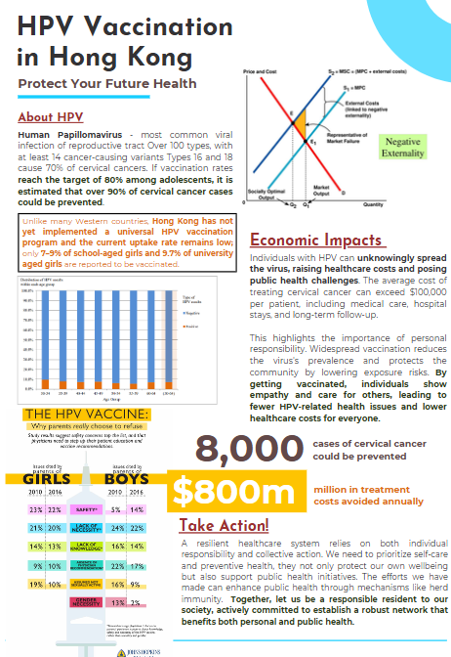
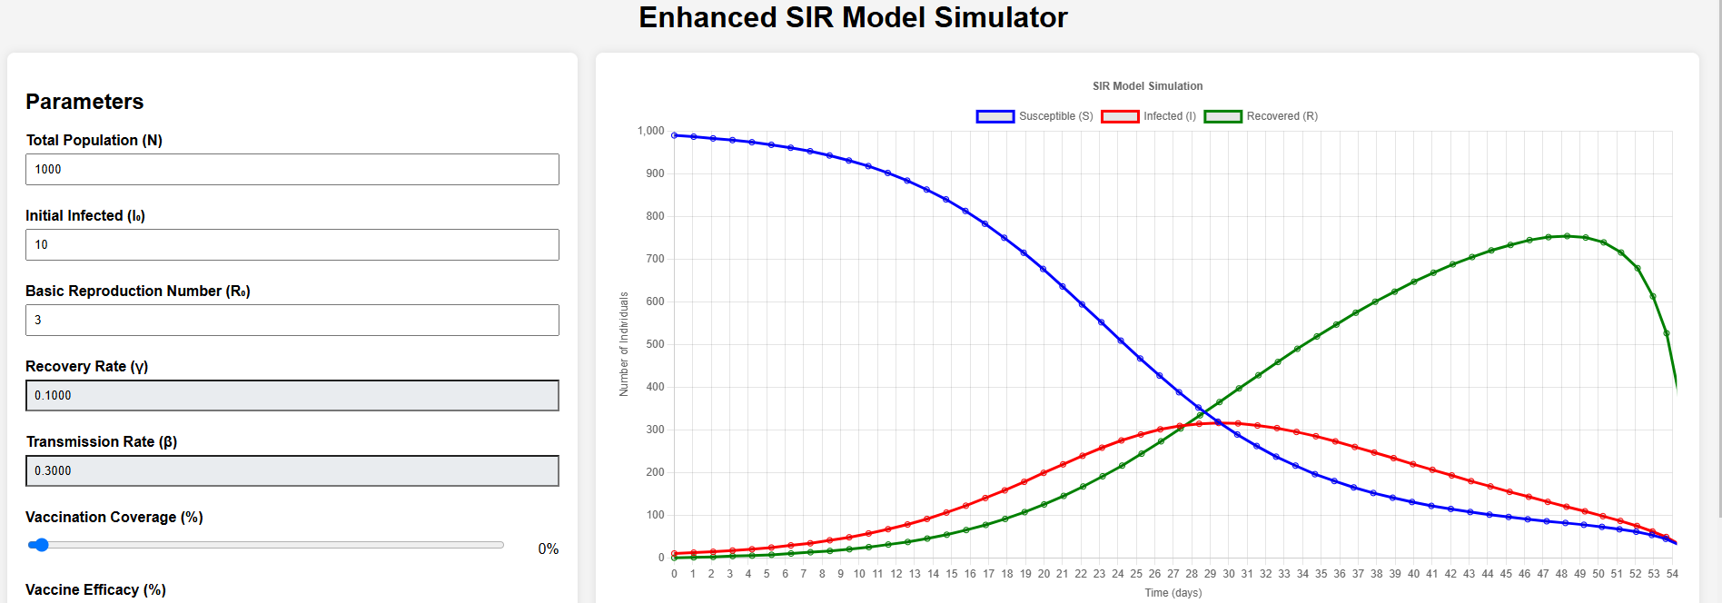

Without Vaccine for HPV (0% Vaccine coverage) | With Vaccine for HPV (30% Vaccine coverage) | With Vaccine for HPV (65% Vaccine coverage)
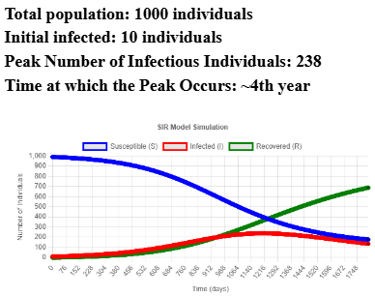 | 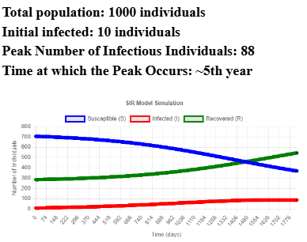 | 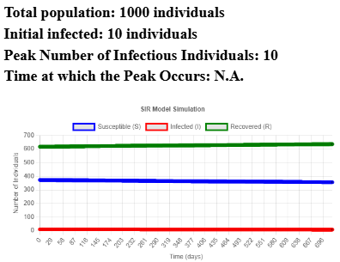
Reference:
- Albrecht, B. C., & Rajagopalan, S. (2023). Inframarginal externalities: COVID-19, vaccines, and universal mandates. Public Choice, 195(1-2), 55-72. https://doi.org/10.1007/s11127-022-01006-z
- Bloom, B. S. (1956). Taxonomy of educational objectives: The classification of educational goals. Longmans.
- Curriculum Development Council. (2017). Secondary education curriculum guide booklet 2 learning goals, school curriculum framework and planning. Education Bureau HKSARG. https://www.edb.gov.hk/attachment/en/curriculum-development/major-level-of-edu/secondary/curriculum-guides-documents/SECG_booklet_2_en.pdf
- Education Bureau. (2021). Value education curriculum framework: Pilot version. https://www.edb.gov.hk/attachment/tc/curriculum-development/4-key-tasks/moral-civic/Value%20Education%20Curriculum%20Framework%20%20Pilot%20Version_trimmed.pdf
- Education Bureau. (2024). Campus mental health - Promotional resources for schools. https://mentalhealth.edb.gov.hk/tc/promotion-at-the-universal-level/promotional-resources-for-schools/121.html
- Education Bureau. (2007a). Economics curriculum and assessment guide (Secondary 4-6). https://www.edb.gov.hk/attachment/en/curriculum-development/kla/pshe/7.Econ_C&A_Guide_updated_e_(2015.11.24)_r.pdf
- Education Bureau. (2007b). Science education key learning area biology curriculum and assessment guide (Secondary 4-6). https://www.edb.gov.hk/attachment/en/curriculum-development/kla/science-edu/Bio_C_and_A_Guide_updated_e_20151126.pdf
- Fullan, M., Quinn, J., & McEachen, J. (in press). New pedagogies for deep learning: Leading transformation in schools, districts and systems. Corwin Press.
- Healthwatch Barnet. (n.d.). Protect yourself against COVID-19. https://www.healthwatchbarnet.co.uk/advice-and-information/2022-04-21/protect-yourself-against-covid-19
- National Geographic Society. (2024). Herd immunity: Strength in numbers. https://education.nationalgeographic.org/resource/herd-immunity-strength-numbers/
- World Health Organization. (2024). Immunization coverage and vaccine-preventable diseases. https://www.who.int/data/gho/data/themes/topics/sdg-target-3_b-development-assistance-and-vaccine-coverage

